**AC SUPERPOSITION**

**LAB # 06**



**Fall 2022**

**CSE-203L Circuit & Systems-II Lab**

**Submitted by: Suleman Shah**

**Registration No. : 21PWCSE1983**

**Class Section: C**

**“On my honor, as student of University of Engineering and Technology, I have neither given nor received unauthorized assistance on this academic work.”**

**Submitted to:**

**Engr. Faiz Ullah**

**DATE: 29 November 2021**

**Department of Computer Systems Engineering**

**University of Engineering and Technology, Peshawar**

**OBJECTIVES:**

* To examine the analysis of multi-source AC circuits using the superposition theorem.
* To use sources with different frequencies and illustrate the contributions of each source to the combined result.

**THEORY:**

The superposition theorem can be used to analyze multi-source AC linear bilateral networks. Each source is considered in turn , with the remaining sources replaced by their internal impedance, and appropriate series parallel analysis techniques employed. The resulting signals are then summed to produce the combined output signal. To see this process more clearly, the exercise will utilize two sources operating at different frequencies. Note that as each source has a different frequency, the inductor and capacitor appear as different reactance to the two sources.

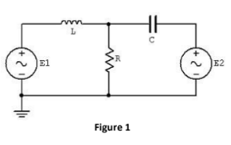

**EQUIPMENT:**

* AC function generators
* Oscilloscope

**COMPONENTS:**

* 0.1uF
* 10mH
* 1kΩ

**PROCEDURE:**

To test the superposition theorem, sources E1 and E2 will be examined separately and then together.

**SOURCE ONE ONLY:**

* Consider the circuit of figure 1 with C=0.1uF, L=10mH, R=1kΩ, using only source E1=2Vp-p at 1Khz and with source E2 replaced by a 0V voltage source represented as a short circuit. Using standard series parallel techniques; calculate the voltages across R. Record the results in Table 1.
* Build the circuit of Figure 1 using C=0.1 μF, L=10mH, and R=1kΩ. Replace E2 with 0-V voltage source represented as a short circuit. Set E1 to 2V p-p at 1 kHz, unloaded. Place probe one across E1 and probe two across R. Measure the voltages across R, and record in Table 1.

**SOURCE TWO ONLY:**

* Consider the circuit of Figure 1 using only source E2=2 V p-p at 10 kHz and with source E1 replaced by 0-V voltage source represented as a short circuit. Using standard series-parallel techniques; calculate the voltages across R. Record the results in Table 2.
* Replace the short circuit with source E2 and set it to 2Vp-p at 10 kHz, unloaded. Replace E1 with 0-V voltage source represented as a short circuit. Place probe one across E2 and probe two across R. Measure the voltages across R and record in Table 2.

**SOURCE ONE AND TWO:**

* Consider the circuit of Figure 1 using both sources, E1=2Vp-p at 1 kHz and E2=2Vp-p at 10 kHz. Add the calculated voltages across R from Tables 1 and 2. Record the results in Table 3.
* Replace the short circuit with source E1 and set it to 2Vp-p at 1 kHz, unloaded. Both sources should now be active. Place probe one across R. Measure the voltages across R, and record in Table 3.
* Repeat the experiment for 1uF capacitor, 1mH inductor and 1kΩ resistor.

**OBSERVATIONS:**

**MATLAB CODES AND CALCULATIONS:**

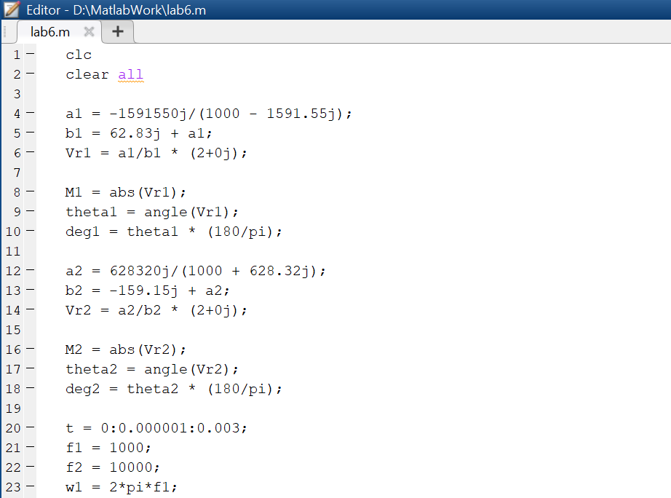

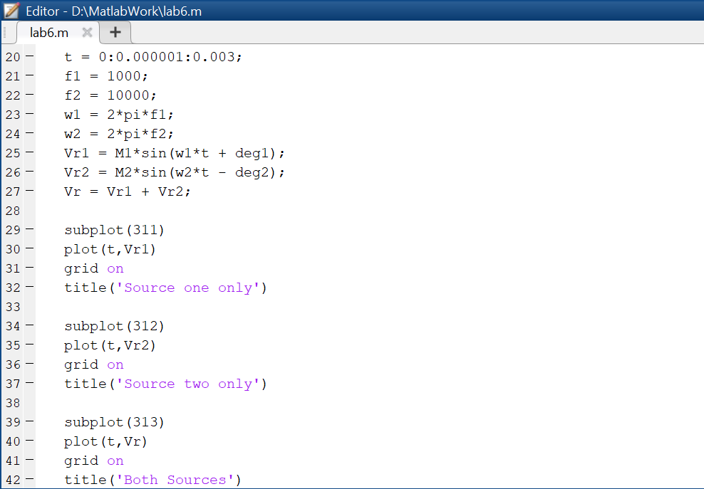

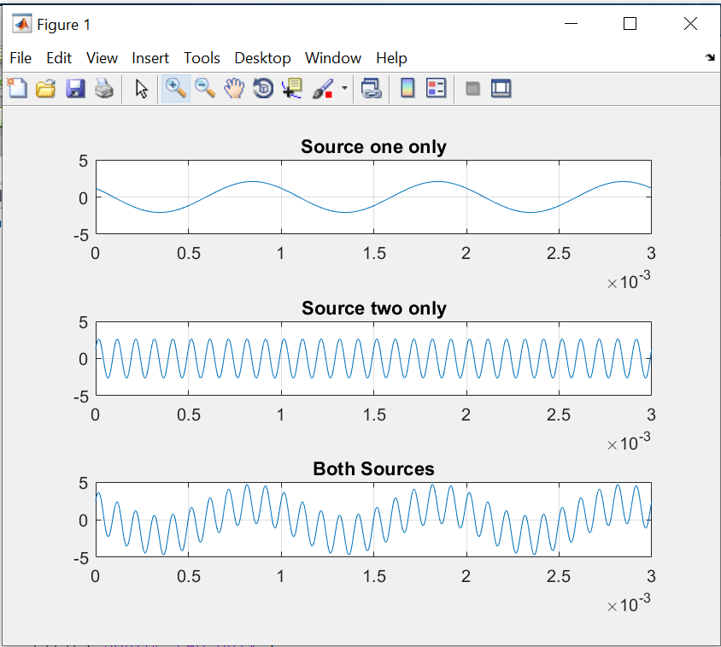

**DATA TABLES:**

**SOURCE ONE ONLY:**

**TABLE 1**

|  |  |  |  |
| --- | --- | --- | --- |
|  | **Theoretical** | **Experimental** | **%Deviation** |
| **VR** | **2.077** | **2.12** | **2.07%** |

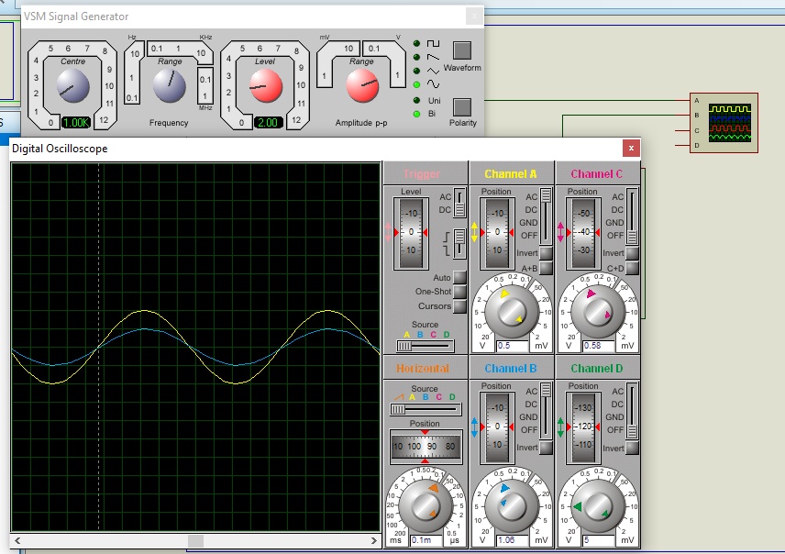

**SOURCE TWO ONLY:**

**TABLE 2**

|  |  |  |  |
| --- | --- | --- | --- |
|  | **Theoretical** | **Experimental** | **%Deviation** |
| **VR** | **2.620** | **2.56** | **2.29** |

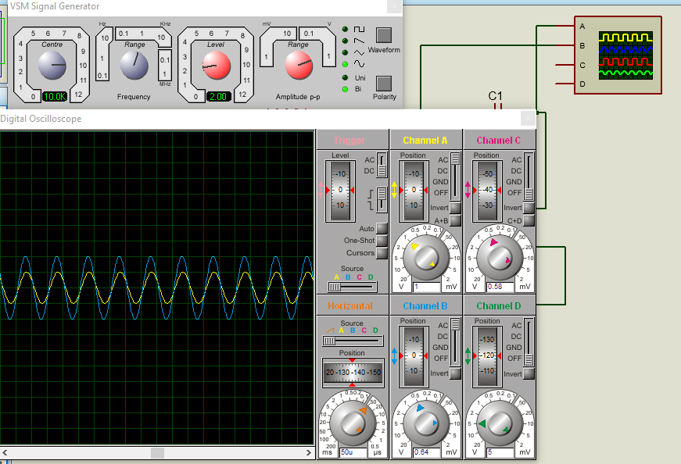

**SOURCE ONE AND TWO:**

**TABLE 3**

|  |  |  |  |
| --- | --- | --- | --- |
|  | **Theoretical** | **Experimental** | **%Deviation** |
| **VR** | **4.69** | **4.64** | **1.06%** |

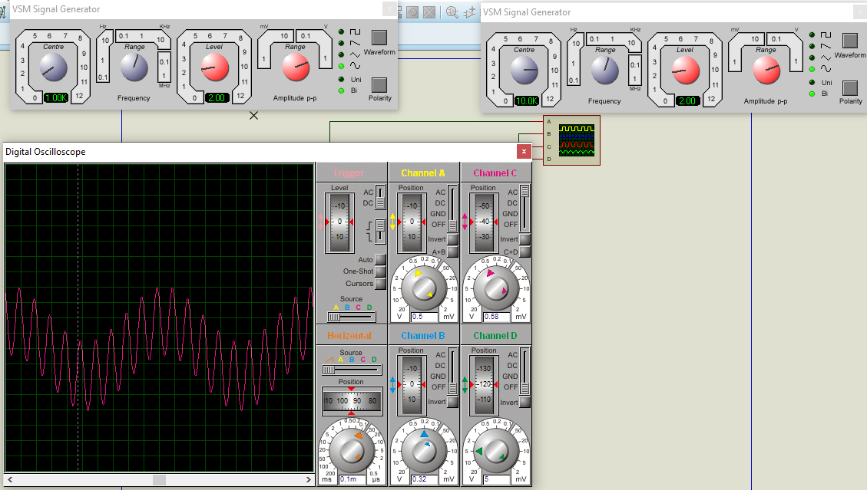

**ANSWERS OF QUESTIONS:**

Q1: Why must the sources be replaced with a 50 Ω resistor instead of being shorted?

ANS: current flows in the least resistance path, for current to not flow in the path of second source when it is removed we short its path with appropriate resistance value which in this case, which in this case is 50 Ω.

Q2: Do the expected maxima and minima from step 6 match what is measured in step 7?

ANS: No. They don’t.

Q3: Does one source tend to dominate the 1kΩ resistor voltage or do both sources contribute in nearly equal amounts? Will this always be the case?

ANS: Clearly from the table 1 and 2, the ac source with greater frequency (10k Hz) dominate over less frequency (1k Hz) source in spite of having same peak to peak voltage (2V) also the source with more peak-to-peak voltage will contribute more to the 1k resistor. They will equally contribute when both sources have same peak to peak voltage and frequency.

**CONCLUSION:**

We can conclude that Superposition theorem can also be applied to AC Circuits